

Contact: Jeff Swartz
Executive Director
Salem Chamber of Commerce
265 Essex Street, Suite 101
Salem, MA 01970
978-744-0004
Jeff@salem-chamber.org

For Immediate Release
/ / /
Kickoff the season at the Salem Chamber's 29th Annual Haunted Happenings Grand Parade on Thursday, October 1st at 6:30PM, presented by Prime Group Shetland Park, The House of the Seven Gables, Salem Witch Museum, and St. Jean's Credit Union. We are extremely grateful for the support of our Presenting Sponsors. We would not be able to host this local-favorite annual event without their generous contribution!
This year’s parade will feature the theme “Old-School Halloween”! As we celebrate Salem400+ this year, we're looking back at the evolution of Halloween through the ages. From the ancient traditions of Samhain to classic trick-or-treating, homemade costumes, and even the nostalgia of '90s Halloween movies, we can't wait to see your interpretation. Our Grand Marshall this year is Aubry Bracco – four-time contestant on Survivor and the recent winner of Survivor 50 earlier this year. Aubry has deep connections to Salem, previously living in the city and was the founding editor of the Salem Patch. We are excited to celebrate her success with her selection as our Grand Marshall and Aubry is thrilled to celebrate a community that holds such a special place in her heart.
The evening should be a night full of color, pageantry, music, and the enthusiasm of thousands of Salem’s students from kindergarten to college plus many local businesses and non-profits. Their participation is what makes this a highly successful, cherished event for our community.
Salem Police will begin road closures around 4PM. The parade commences from Shetland Park at 6:30PM and weaves thru Downtown Salem to Salem Common, ending at approximately 8PM. The pedestrian safety barriers will return again, lining both sides of the parade route. Gaps in the barriers for pedestrian access before the parade starts will remain open until 6:15PM (See route & gaps map below). Once the barrier gaps are shut at 6:15PM, there will be a single crossing point at the intersection of Front Street and Washington Street that will remain open for the duration of the parade for people to safely cross. We extend a huge thank you to all of our volunteers who will help make the event safe and successful.
To ensure the success of this event, the Salem Chamber requests the support of the Salem business community. In addition to our great Presenting Sponsors, we want to thank our Banner Sponsors: Atlantic Toyota, Coffee Time Bake Shop, Desjardin Insurance Agency, Eastern Bank, Haunted Warren Museum, Peabody Essex Museum, Rockland Trust, Salem State University, The Hive Workspace and Business Center, and Witch City Walking Tours! Lastly we are grateful for additional support of our Friends of the Parade: Black Cat Curiosity Shoppe & Tours, Blackcraft, Cheetah DJ & Photography, Dóchas House of Yoga, Institution for Savings, Metro Credit Union, Palmer Cove Yacht Club, The Sea Wych Salem, and When Seconds Count. Please help us show our gratitude to our sponsors by showing them your support.
We are looking forward to a fun, safe, and successful Haunted Happenings Grand Parade on October 1st!
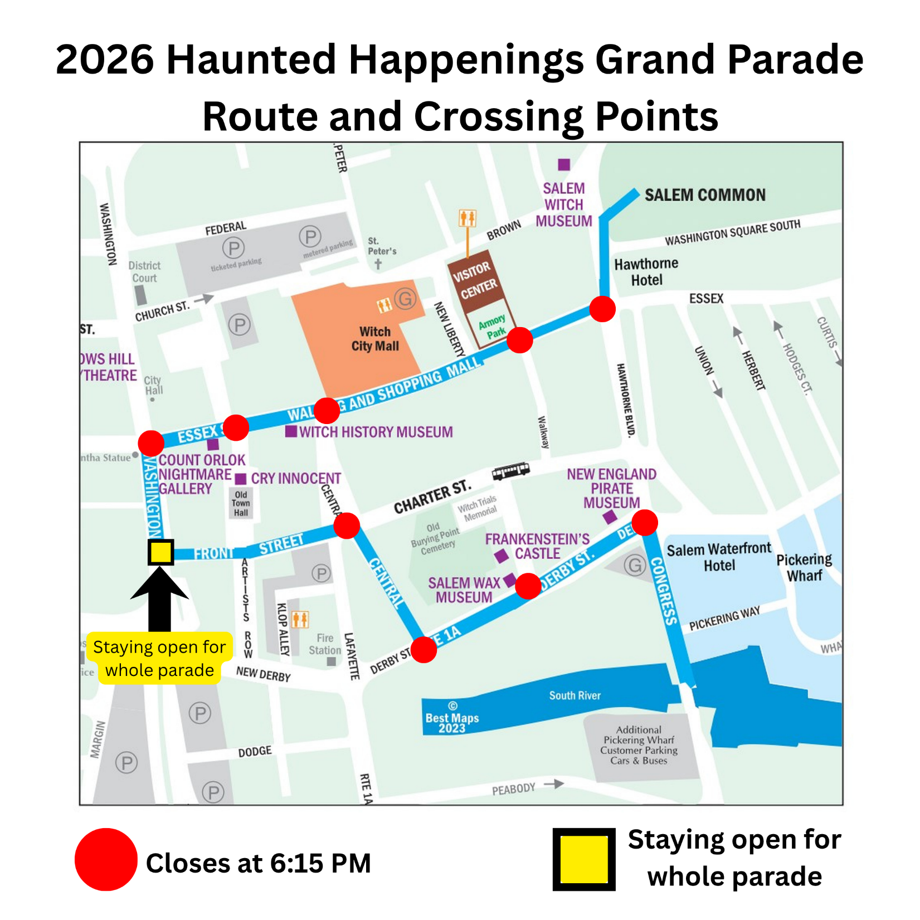

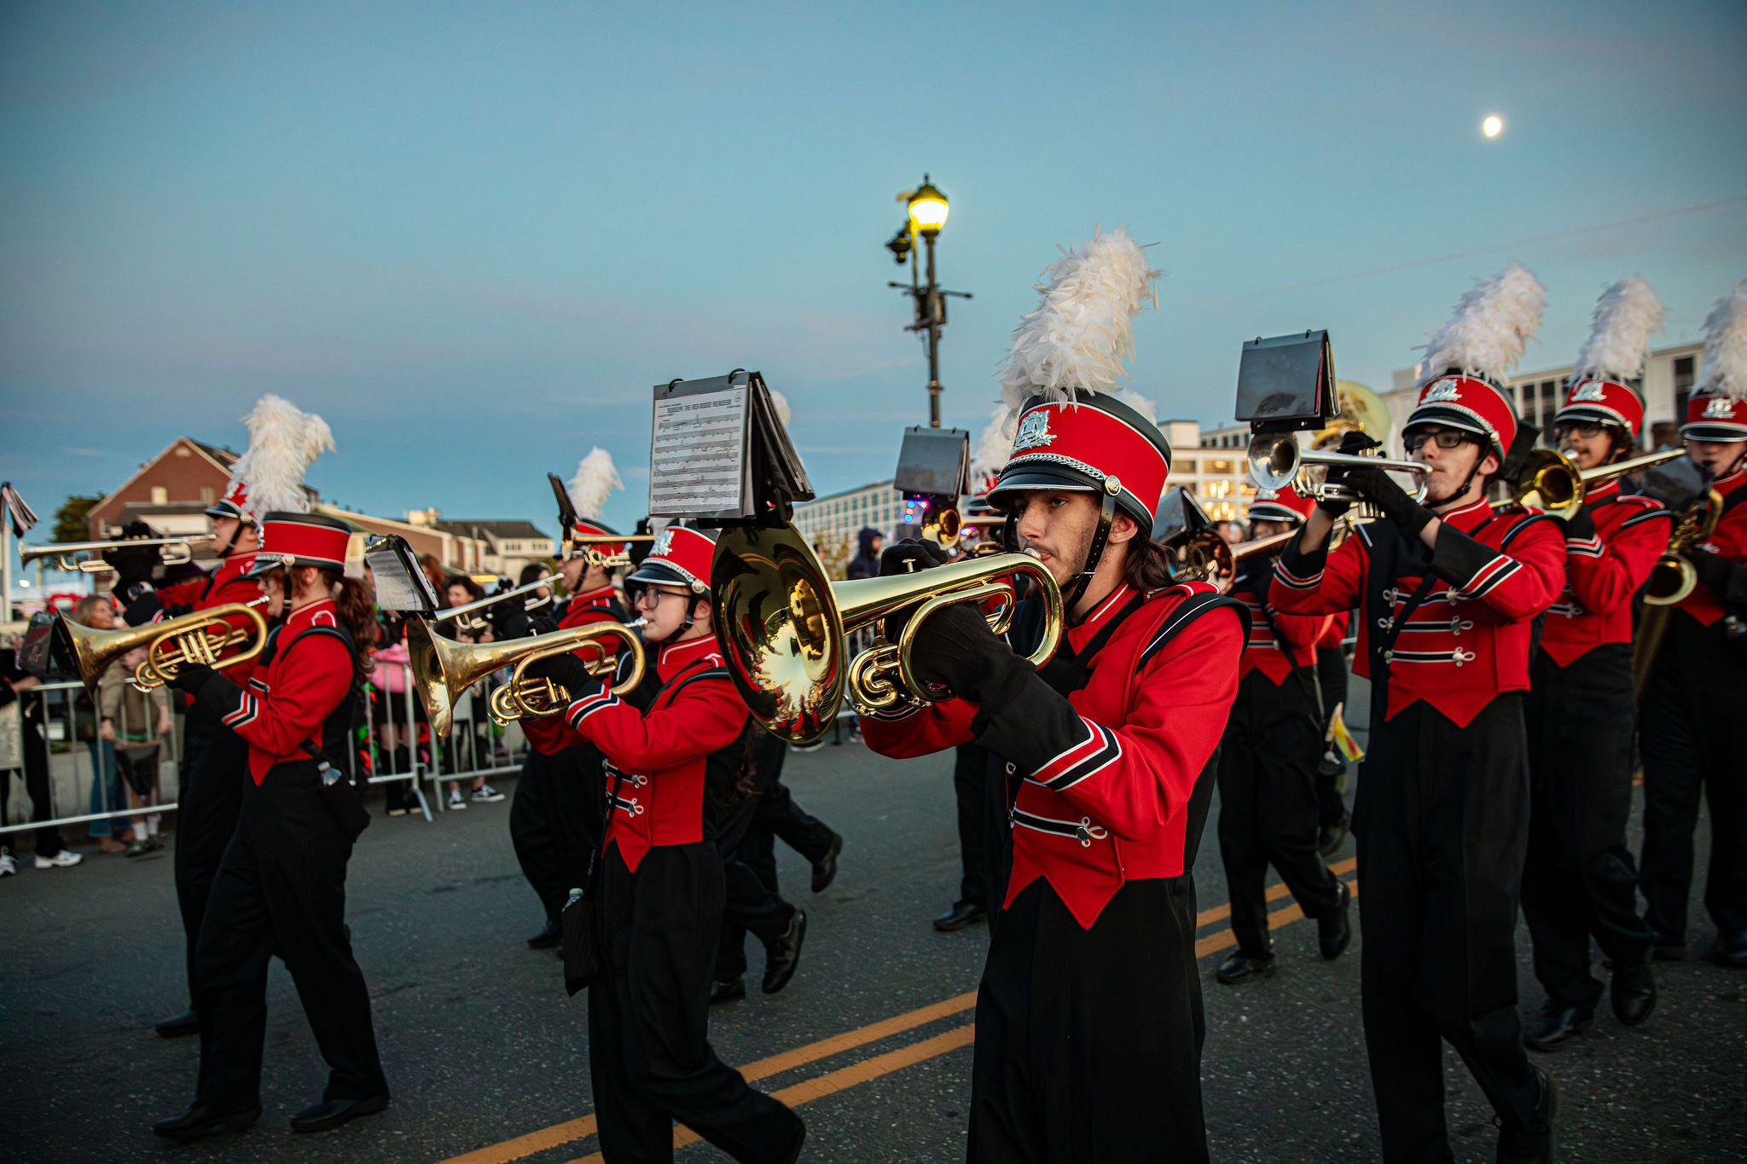
📸 Attached photo of Marching Band- credit to The Creative Collective.

